FOR FREELANCERS
The goal of this is to call attention to the elements and factors that clients may not be considering when it comes to targeting BIPOC consumers in research- from language to concepts that may or may not apply to different cultural groups and why, the goal is to make sure that the work is as representative and as inclusive as possible at every touch point and for all audiences.

Review the document below.
- Take in to account who the guests are and what the goal and objectives of the project are.
- Review the questions- how they’re being asked, what is being asked, and what is left out of the equation and provide suggestions for how to improve the document.
- Add in notes/comments to each area (click review, “new comment” in the navigation bar)

Objectives:
Objective: The “CLIENT” team is working towards launching a new brand in the home space. In order to ensure this brand will meet a wide range of our guests’ aesthetic needs, we’re looking to explore 4 different aesthetic ‘ways in’ to this brand.

Identifying the strongest performer(s) and areas to optimize will help the trend team refine and crystalize the design vision moving forward.

The team is working to create an inclusive design vision, and wants to ensure we’re learning from guests representing a wide range of dimensions of difference, including ethnicity.

Qualified Respondents:
Guests who have planned or plan to purchase home décor or home goods

Subgroups:
- Race (AA, Hispanic, Asian)

Screener

Confidentiality
S1. Please read the following statement.

By taking this survey, you understand that information you receive from participating in this survey may include confidential information (including but not limited to images, product descriptions, and videos). You agree that you will not disclose confidential information, including your participation, to any third party without “CLIENT”’s prior express written consent, unless required by law or legal process.

- I agree to these terms and conditions
- I do not agree to these terms and conditions [END SURVEY]

“CLIENT” Purchase P12M
S2. Which best describes when you last shopped at “CLIENT” for any item? Select one.

- In the past week
- In the past month
- In the past 6 months
- In the past year
- In the past two years [TERM]
- More than two years ago [TERM]

Purchased/plan to purchase
S3. Have you purchased any of the following in the past six months or do you plan on purchasing any of the following in the next six months? Select all that apply.

[RANDOMIZE]
- Seasonal Home décor (not including furniture)
- All-Season Home décor (not including furniture)
- Bath items – Bath towels, shower curtains, bathroom accessories, etc.
- Bedding - Sheets, pillowcases, comforters, duvet covers, etc.
- Rugs
- Dining room furniture
- Kitchen appliances
- Living room furniture
- Patio/outdoor furniture
- Bedroom furniture
- None of the above [ANCHOR, EXCLUSIVE]

[TERM IF 11 SELECTED]

Retailers shopped
S4. At which of the following retailers did you purchase home goods or products in the past six months? Select all that apply.

[RANDOMIZE]
- Amazon
- Pottery Barn
- Target
- Walmart
- Wayfair
- Kohl’s
- Home Goods/TJ Maxx/Marshall’s
- Dollar store/Dollar Tree
- Crate & Barrel
- West Elm
- Macy’s
- Other Specify [ANCHOR]
- I have not purchased home goods or products in the past six months. [ANCHOR, EXCLUSIVE]

Age
S5. What is your age?

- Under 18
- 18-24
- 25-34
- 35-44
- 45-54
- 55-64
- 65-74
- 75+
- Prefer not to say

25% Genz, 50% Millennial, 10% GenX, 10% Boomer

Gender
S6. Are you…?

- Male
- Female
- Other

HHI
S7. What is your annual house hold income?

- Below 24k [TERM]
- 25k – 34k [TERM]
- 35k – 49k
- 50k – 74k
- 75k –100k
- 100k +

Race
S8. What is your race? Please select all that apply.

- White or Caucasian [TERM]
- African American [QUALIFY AS AA QUOTA]
- Hispanic [QUALIFY AS HISPANIC QUOTA]
- Asian [QUALIFY AS ASIAN QUOTA]
- Other [CLASSIFY AS OTHER]

Location
S9. Where do you currently live? WRITE IN

RECRUIT A REGIONAL MIX
- NORTH EAST
- SOUTH EAST
- SOUTH WEST
- MIDWEST
- WEST COAST

Methodology

2hr In-Home Ethnographies

We will be interviewing respondents at home and accompany them on a shopping activity

Main Q’re

Mood Board Test

Intro1. We’d like get your thoughts on a new home goods brand, which could offer a wide range of products including furniture, bedding/bath, décor, etc.

What you’ll see is an example of the different aesthetics and styles of products this brand could carry, but it is not meant to represent actual products. Rather, it should help you get a feel for the intention and expression of the brand.

We don’t want you to focus too much on specific products in the images, but rather as the collection of the images as a whole, so that you can get an understanding of the overall aesthetic/look of this brand.

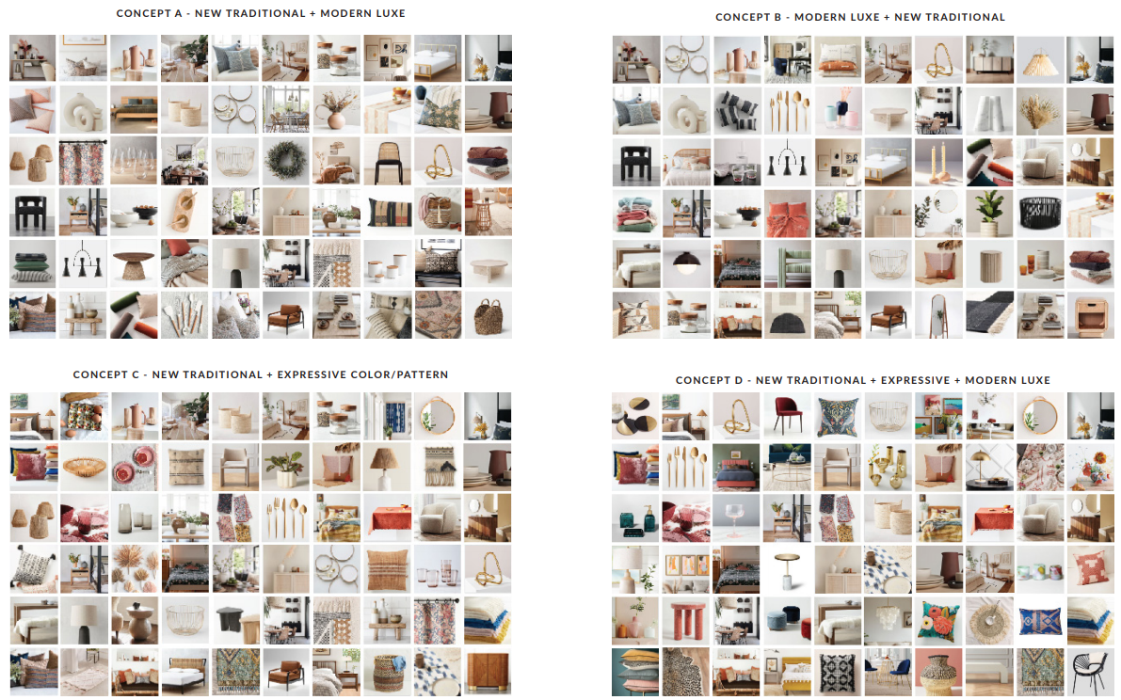

Likeability
[Random Order Display each of 4 Concepts]
Q1. How much do you like or dislike the overall look and feel of this brand’s style?

- Like a lot
- Like somewhat
- Neither like nor dislike
- Dislike somewhat
- Dislike a lot

Ranking
Q2. Please rank the home goods brand collections from your favorite to your least favorite. To re-order the images, please click and drag the image to the correct order, with your favorite image at the top. [Rank Images]

Q2. [Display Q2 Rank 1] Why did you prefer this image [Display Q2 Selected] in terms of the overall aesthetic/look of the brand’s style?

Purchase Intent
[DISPLAY FAVORITE CONCEPT]
Q4. How likely or unlikely are you to purchase from a brand with this overall look and feel?

- Extremely likely
- Very likely
- Somewhat likely
- Not very likely
- Not at all likely

Uniqueness
[DISPLAY FAVORITE CONCEPT]
Q5. Compared to other home décor brands you are familiar with, how unique is this overall look and feel of this brand’s style?

- Extremely unique
- Very unique
- Somewhat unique
- Not very unique
- Not unique at all

Retailer Fit
[DISPLAY FAVORITE CONCEPT]
Q6. With which of the following retailers does this home décor brand’s style fit best?

[RANDOMIZE]
- Amazon
- Pottery Barn
- Target
- Walmart
- Wayfair
- Kohl’s
- Home Goods/TJ Maxx/Marshall’s
- Dollar Store/Dollar Tree/Dollar General
- Crate & Barrel
- West Elm
- Macy’s
- None of the above

Q6a. [If Q6 NOT 12] Why did you feel that this brand’s style fits best with [Pipe Q6]?

“CLIENT” Fit
[DISPLAY FAVORITE CONCEPT]
Q7. How well do you think a home décor brand with this overall look/feel fits at “CLIENT”?

- Fits extremely well
- Fits very well
- Fits somewhat well
- Does not fit very well
- Does not fit at all

Concept Attributes
Q8. Thinking about the overall look and feel of this brand’s style, how much do you agree or disagree with the following statements? (Strongly agree, Somewhat agree, Neither agree nor disagree, Somewhat disagree, Strongly disagree)

[ROWS, RANDOMIZE]
- The overall look and feel offers enough variety for me to find things I’d like throughout my home
- The color scheme matches with my current/future home décor
- The brand’s style feels inclusive to all types of people
- The patterns match with my current/future home design
- The brand’s style feels inviting

Home Design Fit
Q9. How well do you think this overall look/feel fits with your current or future home design (through the next year)?

- Fits extremely well
- Fits very well
- Fits somewhat well
- Does not fit very well
- Does not fit at all

Fits T2B with home design
Q10. [ASK IF Q9 “overall look/feel fits with your current or future home design (through the next year)?” (Q9=1 OR 2)]
What specifically about the overall look and feel of this home goods brand’s style works well with your current or future home design? Please describe in as much detail as possible.

Fits B3B with home design
Q11. [ASK IF Q9 overall look/feel fits with your current or future home design (through the next year)?” (Q9=3, 4 OR 5)]
What specifically about the overall look and feel of this home goods brand’s style does not work with your current or future home design? Please describe in as much detail as possible.

